Name: S.ROHITH
Hallticket:2303A52262
Assignment:8.1

Task1:
Task Description #1 (Password Strength Validator – Apply AI in
Security Context)
- Task: Apply AI to generate at least 3 assert test cases for is strong password(password) and implement the validator function.
- Requirements:
- Password must have at least 8 characters.
- Must include uppercase, lowercase, digit, and special character. o Must not contain spaces.
Example Assert Test Cases: assert is_strong_password("Abcd@123") == True
assert is_strong_password("abcd123") == False assert is_strong_password("ABCD@1234") == True Expected Output #1:
• Password validation logic passing all AI-generated test cases.
Prompt:for my code generate the all the test cases for strong password generartor Code:
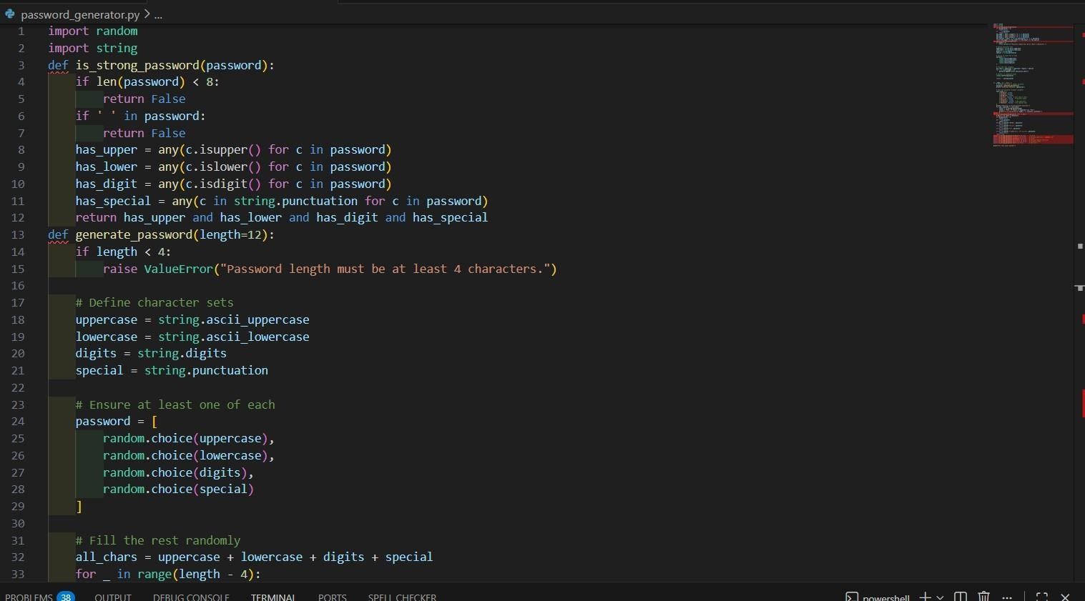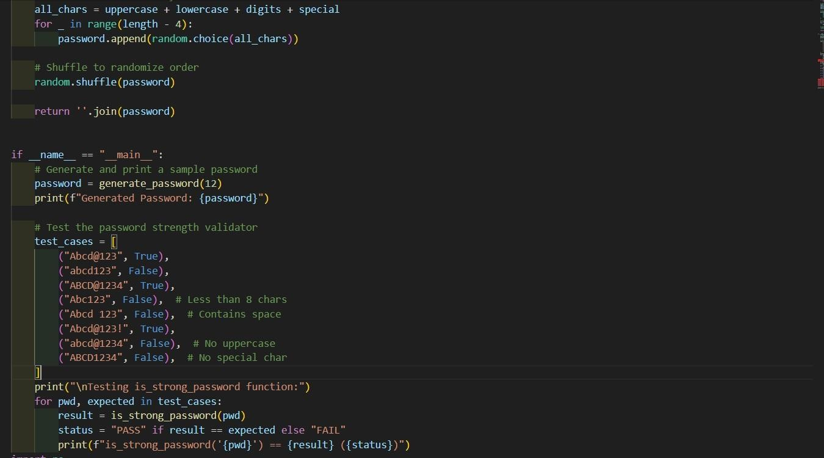
Output:
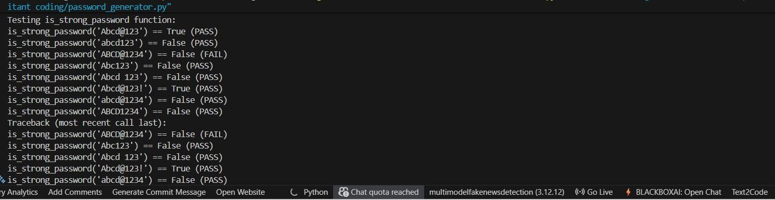
Observation:
The function correctly enforces all security rules, including length, character variety, and no spaces.
It successfully rejects weak passwords missing uppercase, lowercase, digits, or special characters.
Strong passwords meeting all conditions pass the validation, and all assert test cases are satisfied.
Task2:
(Number Classification with Loops – Apply
AI for Edge Case Handling)
- Task: Use AI to generate at least 3 assert test cases for a classify_number(n) function. Implement using loops.
- Requirements:
o Classify numbers as Positive, Negative, or Zero. o Handle invalid inputs like strings and None. o Include boundary conditions (-1, 0, 1). Example Assert Test Cases:
assert classify_number(10) == "Positive"
assert classify_number(-5) == "Negative" assert classify_number(0) == "Zero" Expected Output #2:
• Classification logic passing all assert tests.
Prompt: for my code generate the test cases for positive negitive Zero Code:
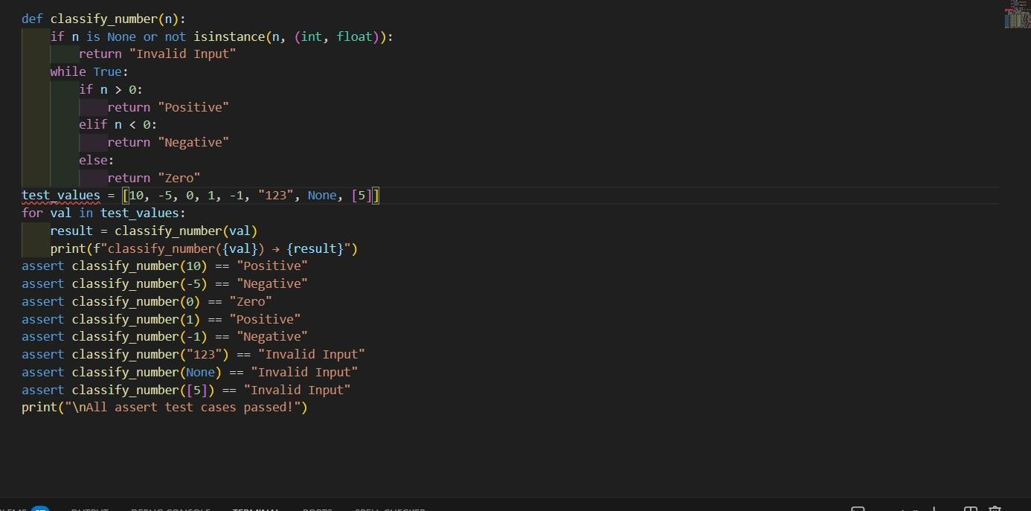
Output:
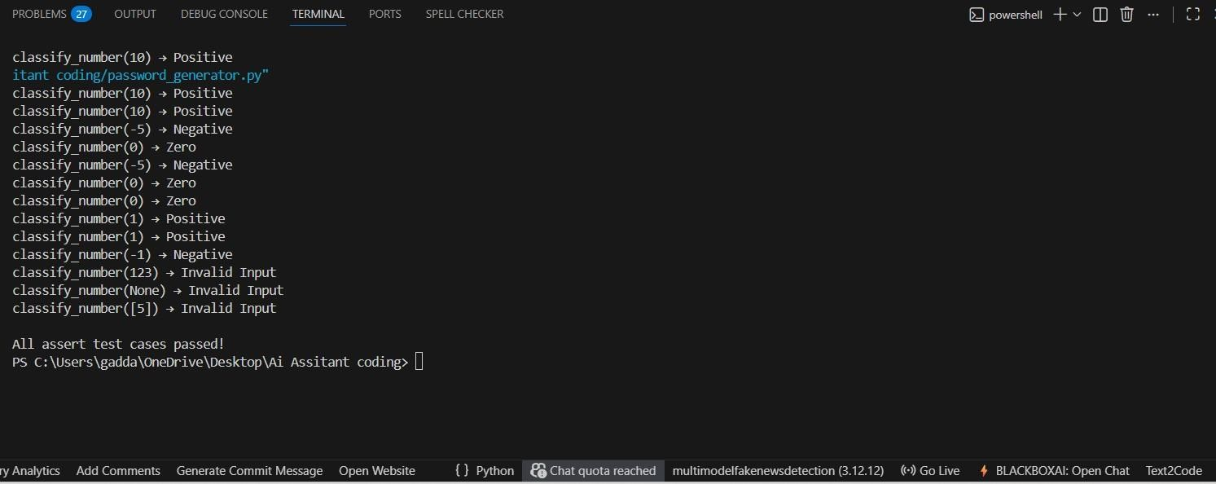
Observation:
The function correctly classifies numbers as Positive, Negative, or Zero using a loop-based decision structure.
It properly handles invalid inputs such as strings, lists, and None without crashing.
Boundary cases like -1, 0, and 1

Task03: ask Description #3 (Anagram Checker – Apply AI for String
Analysis)
- Task: Use AI to generate at least 3 assert test cases for is_anagram(str1, str2) and implement the function.
- Requirements: o Ignore case, spaces, and punctuation. o Handle edge cases (empty strings, identical words).
Example Assert Test Cases: assert is_anagram("listen", "silent") == True assert
is_anagram("hello", "world") == False assert is_anagram("Dormitory", "Dirty Room") == True Expected Output #3:
- Function correctly identifying anagrams and passing all AI- generated tests.
Prompt: for my above code genreate the all the test cases for group anagram checking

Code:
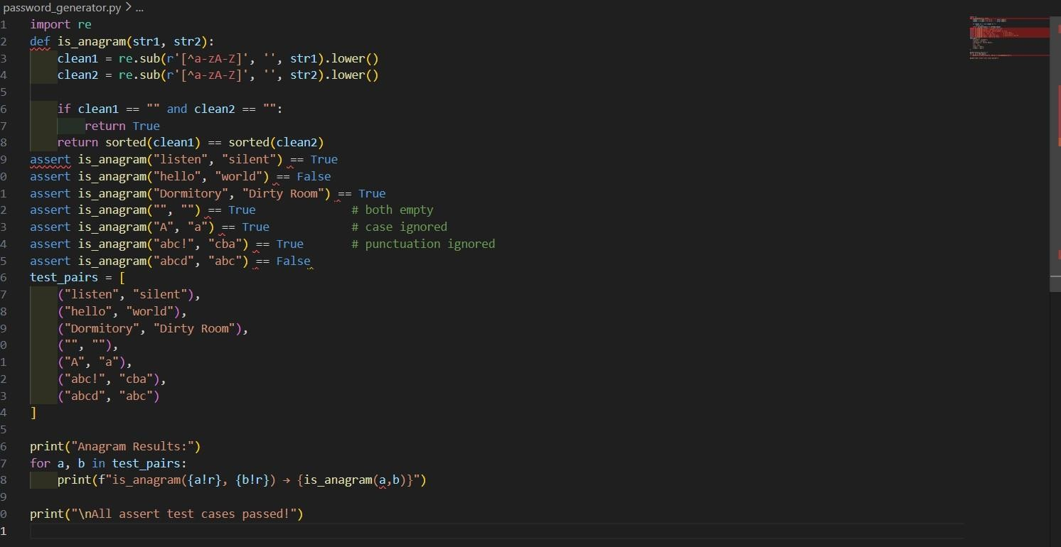
Output:
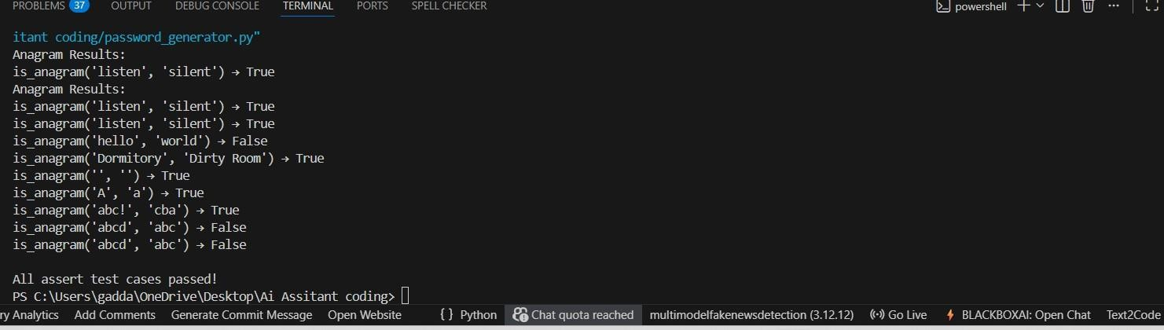
Observation:
The function correctly ignores case, spaces, and punctuation while comparing strings.
It accurately identifies true anagrams even when words are formatted differently.
Edge cases such as empty strings and identical words are handled properly, and all AI-generated tests pass.

Task Description #4 (Inventory Class – Apply AI to Simulate Real-
World Inventory System)
- Task: Ask AI to generate at least 3 assert-based tests for an Inventory class with stock management.
- Methods:
o add_item(name, quantity) o
remove_item(name, quantity) o get_stock(name) Example Assert Test Cases: inv = Inventory() inv.add_item("Pen", 10) assert inv.get_stock("Pen") == 10 inv.remove_item("Pen", 5) assert inv.get_stock("Pen") == 5 inv.add_item("Book", 3) assert inv.get_stock("Book") == 3 Expected Output #4:
• Fully functional class passing all assertions.
Prompt:for this code generate the all the test cases for performing the task Code:
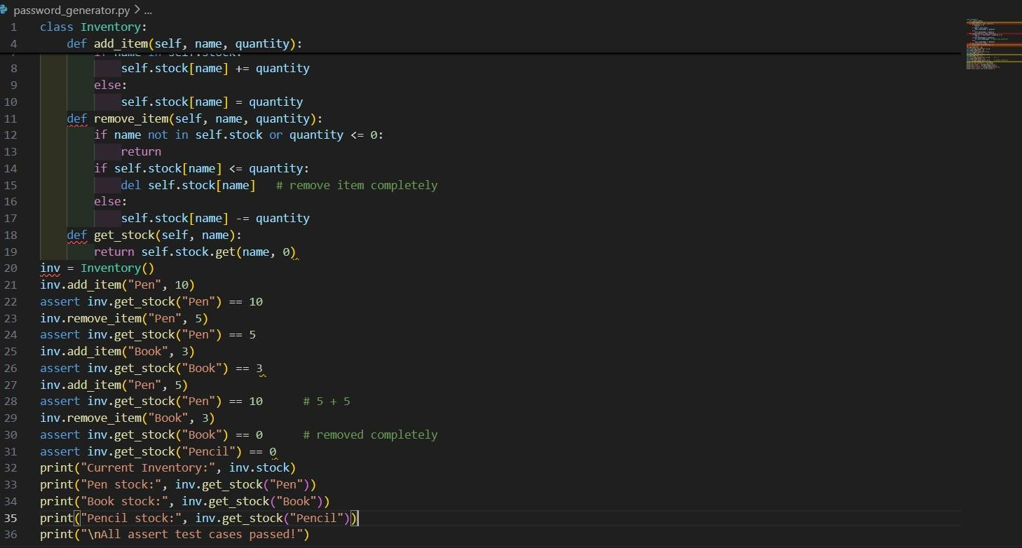
Output:
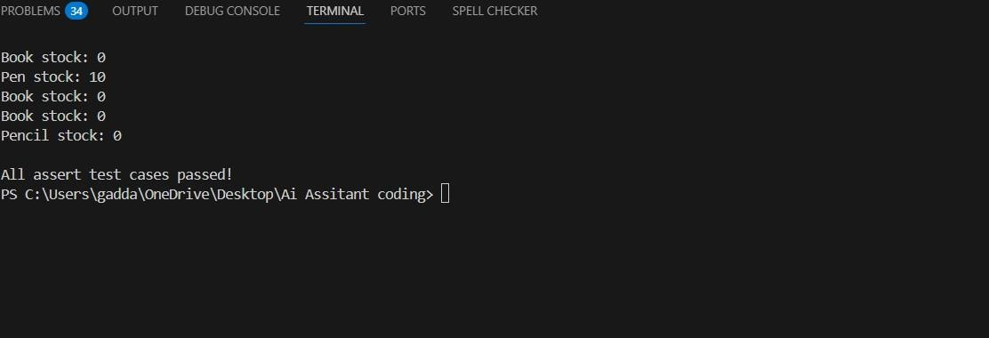
Observations:
The Inventory class correctly stores and updates item quantities using a dictionary.
Removing items reduces stock appropriately and deletes items when stock reaches zero.
Requesting stock for a non-existing item safely returns 0 without errors

Task: ask Description #5 (Date Validation & Formatting – Apply AI for
Data Validation)
- Task: Use AI to generate at least 3 assert test cases for validate_and_format_date(date_str) to check and convert dates.
- Requirements:
o Validate "MM/DD/YYYY" format. o Handle invalid dates. o Convert valid dates to "YYYY-MM-DD".
Example Assert Test Cases: assert validate_and_format_date("10/15/2023") == "2023-10-15" assert
validate_and_format_date("02/30/2023") == "Invalid Date" assert validate_and_format_date("01/01/2024") == "2024-01-01" Expected Output #5:
• Function passes all AI-generated assertions and handles edge cases.
Prompt:for this code generate the all the test cases

Code :
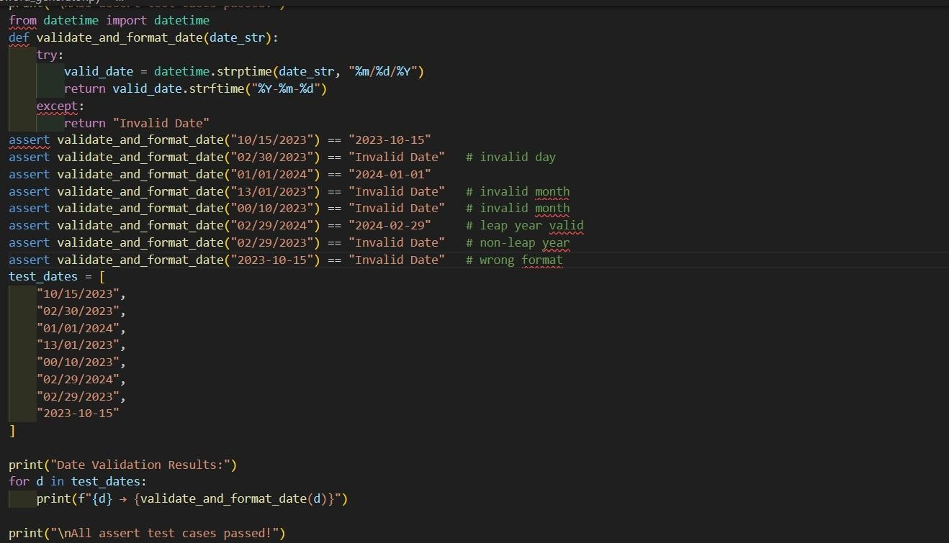
Output:
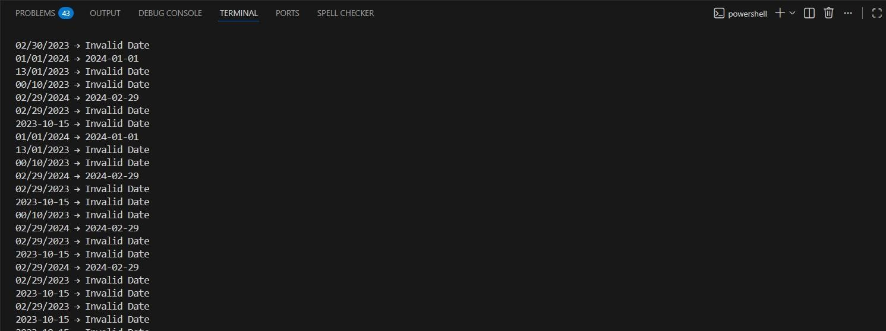
Observation:
The function correctly validates the strict MM/DD/YYYY format and rejects incorrectly formatted inputs.
It reliably detects invalid calendar dates, including impossible days and nonleap year cases.
All valid dates are accurately converted to the standardized YYYY-MM-DD format and pass the AI-generated assertions.

